University:

Course: Deep Learning
Laboratory Work 1
Topic: Logistic Regression – Binary Classification
Student: Rustam Khalimov
Student ID: 23B031473
Instructor: Yerlan Kuzbakov
Date: 05.02.2026

Variant: 3

Variant 3
Problem 3.1
We have:
beta_0 = - 4.0
beta_1 (recency) = 2.8
beta_2 (frequency) = 1.5
x_1 = 0.5 and x_2 = 0.7

- Calculate the log-odds(z) for this customer
We know formula of log-odds(z) it`s:
z = beta_0 + beta_1 * x_1 + beta_2 * x_2 = -4 + 2.8 * 0.5 + 1.5 * 0.7 =
= -4 + 1.4 + 1.05 = -1.55
- Calculate the probability of response
We have formula p = 1 / (1 + e^(-z)) = 1 / (1 + e^(-(-1.55))) ⁓ 0.1751
- Calculate the odds of response
We have formula odds = p / (1 - p) = 0.18 / (1 – 0.18) = 0.18 / 0.82 = 9 / 41 ⁓ 0.2195
- If the company uses a threshold of 0.2, what is the prediction?
Our Predicted probability is 0.1751 and it less than company`s threshold. So the customer is classified as not responding.
- Calculate and interpret the odds ratios for both features
Recency:
OR1 = e^beta_1 = e^2.8 ⁓ 16.4447
Frequency:
OR2 = e^beta_2 = e^1.5 ⁓ 4.4817

Overall interpretation
Recency give much stronger impact on customer response than frequency. Customers who have only recently contacted us are more likely to respond to emails sent to their mail.

Let`s prepare to complete Problem 3.2
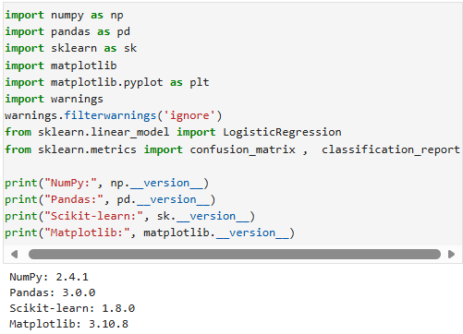
Figure 1. There we importing libraries to complete our problem and there we can see version`s of each libraries.
Interpretation:
It turns out that in "matplotlib.pyplot" there is no attribute "__version__" because of this, I imported matplotlib. separately

Problem 3.2
a)
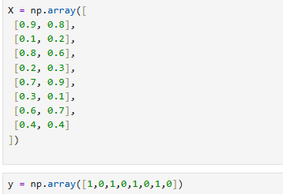
Figure 2. Here we can see array of our problem
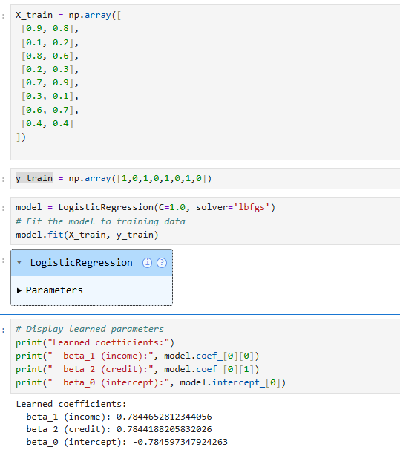
Figure 3. Logistic regression model training and learned coefficients.
Interpretation:
My logistic regression model was trained on the data provided in the assignment. Learned coefficients show both recency and frequency positively affect the likelihood of a response. Values of the coefficients are very similar which indicates that both features have comparable level of influence

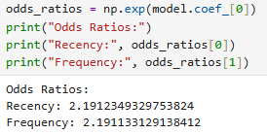
Figure 4. Odds ratios for model features with interpretation.

b)
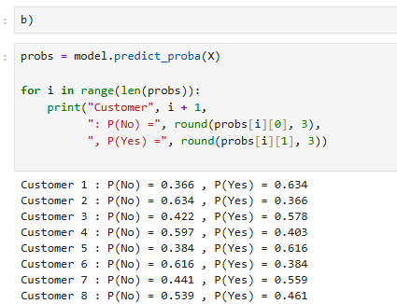
Figure 5. Predicted probabilities for training samples.

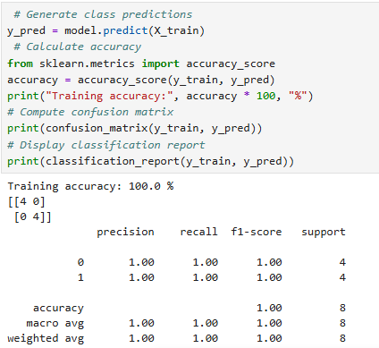
Figure 6. Accuracy, confusion matrix and classification report.
Interpretation:
My model`s predictions were compared with the true class labels. Confusion matrix and the classification report show that the model correctly classified all training samples. The training accuracy is 100% which indicates good performance of the training dataset(in my opinion it because our database is small size).

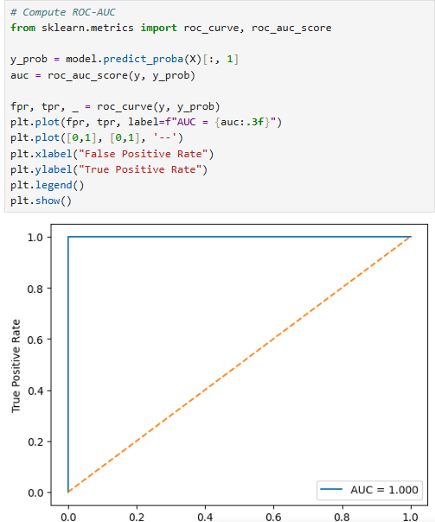
Figure 7. Decision boundary and probability surface visualization.

Learned coefficients beta_1: 0.7845
Learned coefficients beta_2: 0.7844
Learned coefficients beta_0: -0.7846
Odds ratio for x_1: 2.191
Odds ratio for x_1: 2.191
Training accuracy: 100%
ROC-AUC score: 1.00

c)
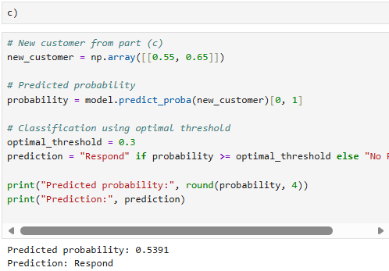
Figure 8. Prediction for a new customer using the optimal classification threshold.
Interpretation:
For new customer with x_1 = 0.55 and x_2 = 0.65, predicted probability of response is approximately 0.539. Using the optimal threshold of 0.3 customer is classified as a responder.

Problem 3.3
We have:
Cost per email = 0.5$
Revenue per responder = 25$
Historical response rete = 12%

- Calculate break-even response probability
break-even probability = Cost per email / Revenue per responder = 0.5 / 25 = 0.02

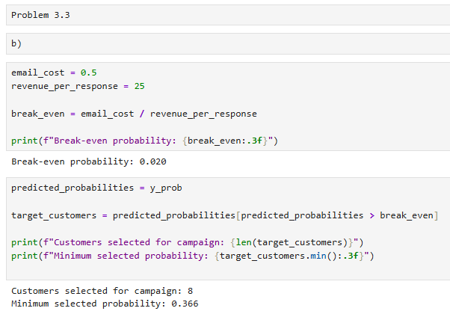
Figure 9. Break-even probability calculation and customer selection for the email campaign.
To determine whether an e-mail newsletter is profitable, the probability of break-even was calculated by dividing the cost of the newsletter by the revenue per response. The final threshold is 0.02.

Clients with a predicted response probability exceeding this value were selected for targeting. Since the model predicts probabilities significantly higher than the break-even level, the target campaign is expected to be profitable.

- Calculate expected campaign profit for 10,000 customers
Expected profit = 10,000 * 0.12 * 25 – 10,000 * 0.5 = 30,000 – 5,000 = 25,000

ANALYSIS QUESTIONS

1. Why does logistic regression use a sigmoid function?
Logistic regression uses a sigmoid function because it converts the result of a linear formula into a value from 0 to 1. This is convenient because such a value can be considered a probability. A linear model can produce numbers less than 0 or greater than 1, which is not suitable for probabilities.

2. What does the 2.5 chance ratio mean for “years of work"?
The 2.5 chance ratio means that each additional year of employment increases the chances of loan approval by 2.5 times if the other conditions do not change. Simply put the longer a person works the higher their chance of getting a loan. For a person without technical knowledge this can be explained as follows: “An additional year of work significantly increases the likelihood of loan approval.”

3. How do I choose the classification threshold for different error costs?
a) False negative errors are more expensive
If skipping a positive case is expensive the classification threshold should be lowered. This will allow you to find more positive cases even if the number of other types of errors increases.
b) False positive errors are more expensive
If false alarms are more expensive the threshold should be raised. In this case the model will become more cautious and will make positive predictions less often.

4. Comparison of logistic regression and perceptron
Logistic regression provides the probability of belonging to a class and the perceptron provides only the class itself. Logistic regression is trained using optimization and perceptron uses a simple algorithm for updating weights. Both models have a linear decision boundary but logistic regression is more convenient in practice as its results are easier to explain.

5. What does high accuracy in training and low accuracy in testing mean?
This means retraining. The model has memorized the training data well but it doesn't work well on the new ones. To solve this problem you can use more data, reduce the complexity of the model or add regularization.

